**Open the Terminal and enter the following command:**

ioreg -l | grep IODisplayEDID

**Obtain your EDID information**

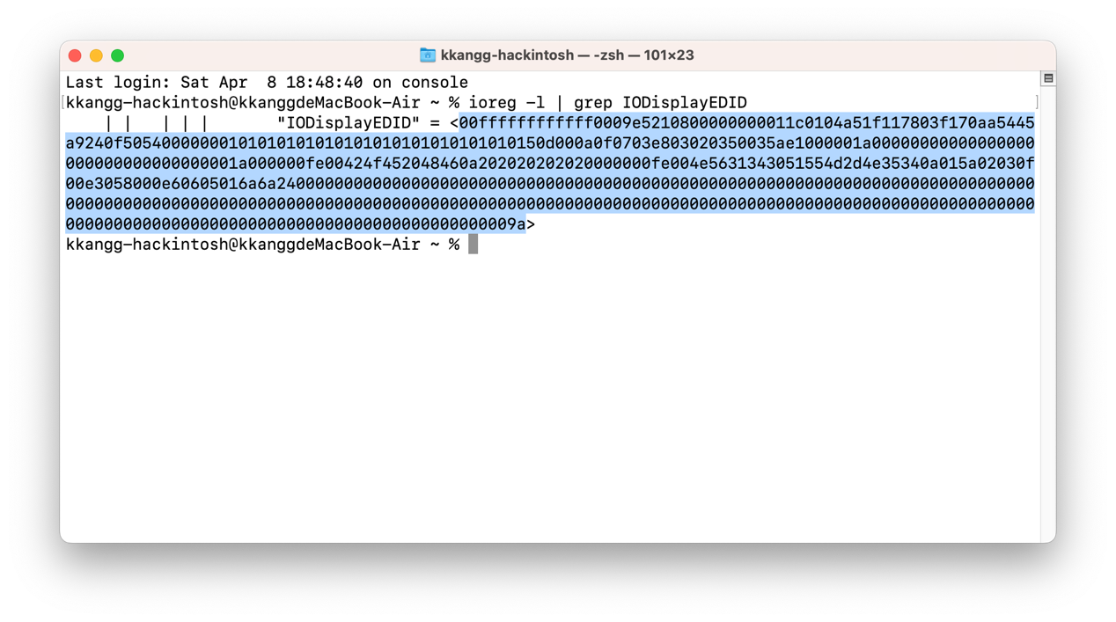

Use **OCAuxiliaryTools** to open the config.plist file for editing.  
Navigate to the **DP** section — find the PCI device at **PciRoot(0x0)/Pci(0x2,0x0)**.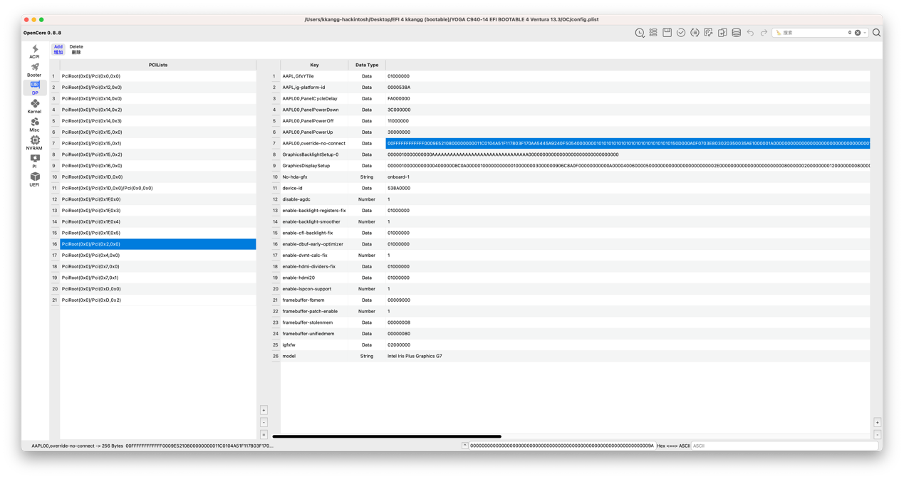

Change the information in the **AAPL00,override-no-connect** field to your own EDID.